Listen to your body
Pay attention to:

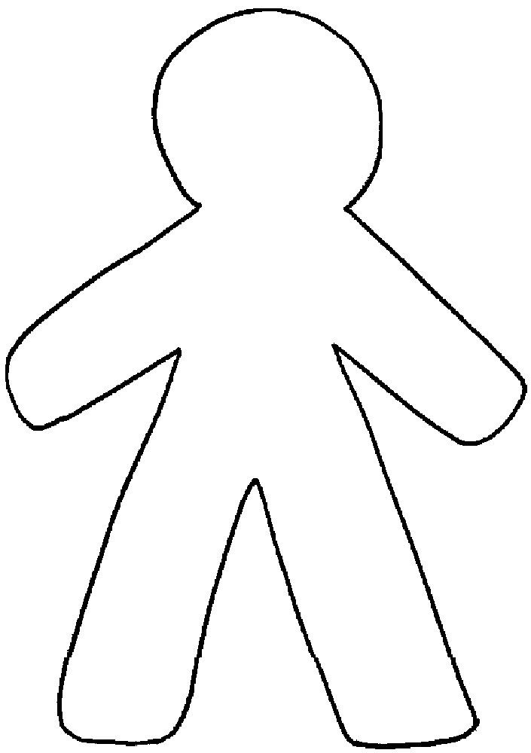
your muscles
your breath
your temperature
your stomach
your heartbeat
How do you experience the energy in your body?
What other sensations do you notice?

