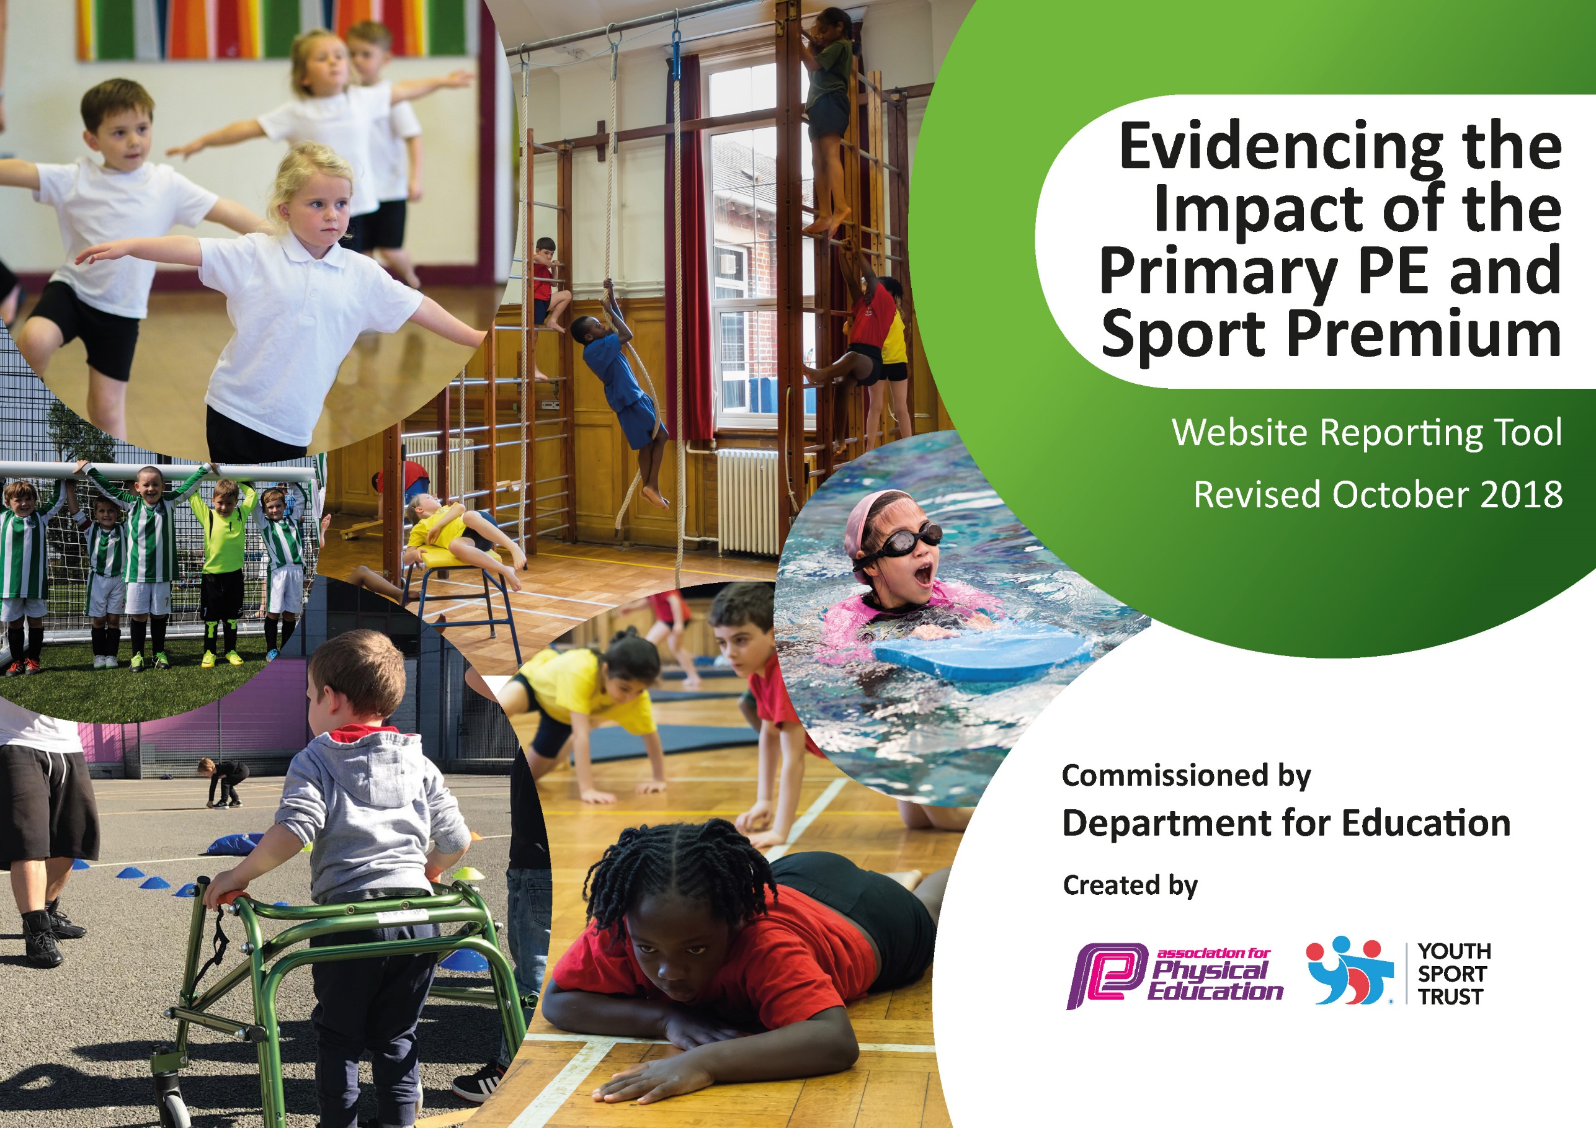
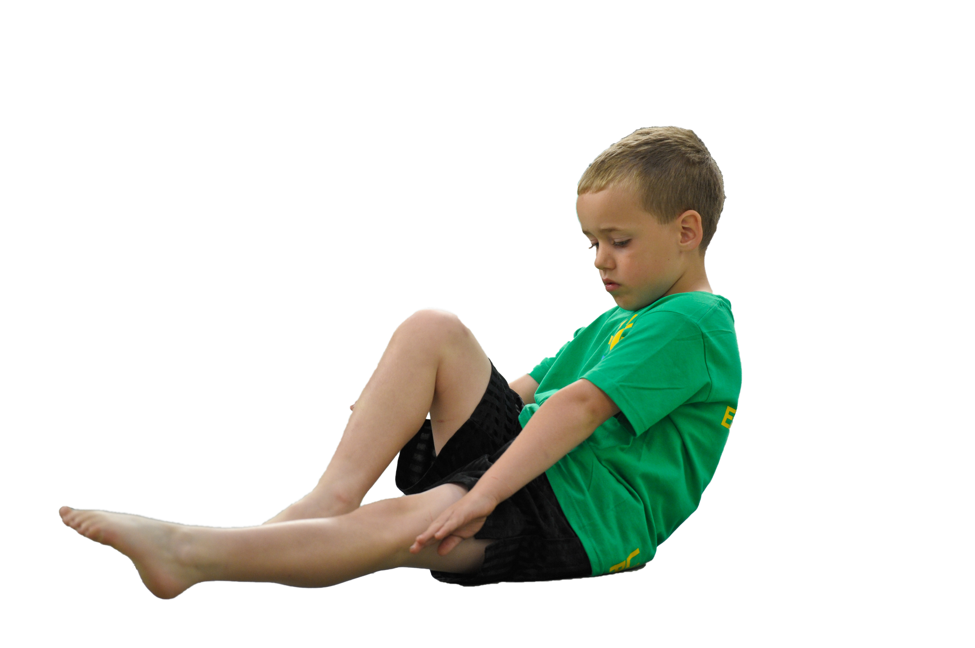
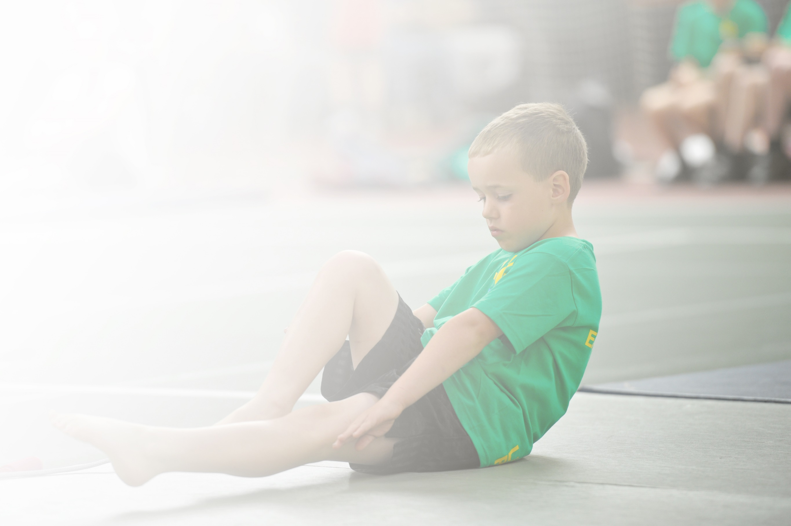
Schools must use the funding to make additional and sustainable improvements to the quality of Physical Education, Sport and Physical Activity (PESPA) they offer. This means that you should use the Primary PE and Sport Premium to:

- Develop or add to the PESPA activities that your school already offer
- Build capacity and capability within the school to ensure that improvements made now will benefit pupils joining the school in future years

Please visit gov.uk for the revised DfE guidance including the 5 key indicators across which schools should demonstrate an improvement. This document will help you to review your provision and to report
your spend. DfE encourages schools to use this template as an effective way of meeting the reporting requirements of the Primary PE and Sport Premium.

We recommend you start by reflecting on the impact of current provision and reviewing the previous
spend. Under the Ofsted Schools Inspection Framework, inspectors will assess how effectively leaders use the Primary PE and Sport Premium and measure its impact on outcomes for pupils, and how effectively governors hold them to account for this.

Schools are required to publish details of how they spend this funding as well as on the impact it has on pupils’ PE and sport participation and attainment by the end of the summer term or by 31 July 2019 at the
latest.
We recommend regularly updating the table and publishing it
on your website throughout the year, as evidence of your
ongoing review into how you are using the money to
secure maximum, sustainable impact. To see an
example of how to complete the table please
click HERE.

Support for review and reflection - considering the 5 key indicators from DfE, what development needs are a priority for your setting and your students now and why? Use the space below to reflect on previous spend, identify current need and priorities for the future.

Key achievements to date: | Areas for further improvement and baseline evidence of need:
Targeted groups of children (Pupil Premium and ELSA.  Participated within virtual competitions (Hinckley & Bosworth School Sport & Physical Activity Network, HBSSPAN).  Sports coach has delivered high quality PE lessons to pupils across the school.  Pupils have attended and participated within a wider range of competitions.  Sports Leaders have supported the school in promoting the profile of sports and PE across the school.  Engaged a wider range of children in afterschool clubs through providing clubs of their interests.  Continued to provide pupils with the wide range of competitive level 1, 2 and qualifying competitions.  Provided new opportunities for EYFS (balance bikes) to further the children’s physical development.  Continued to embed the fundamental skills which the Big Moves programme offered throughout KS1  Provided the subject knowledge required to skilfully teach the National Curriculum requirements.  Promoted the school ethos and values; encouraged pupils to participate as a school team.  Promoted swimming for children who were not able to swim 25 metres from their Year 3 curriculum swimming sessions. | Focus on Pupil Premium Children with the aim to increase participation from previous years.  Continue to participation within virtual competitions (Hinckley & Bosworth School Sport & Physical Activity Network, HBSSPAN).  To continue to build on the success of previous years.  This is something we will continue to endeavour to build on.  Sports leaders to take more ownership of a range of sports activities.  To continue running afterschool clubs through external providers and school staff.  To continue to provide pupils with the wide range of competitive level 1, 2 and qualifying competitions.  CPD opportunities for staff to carry on using balance bikes in EYFS.  To continue the success of Big moves programme.  To continue to provide the subject knowledge required to skilfully teach the National Curriculum requirements.  To continue to promote the school ethos and values; encouraging pupils to participate as a school team.  To continue to promote swimming for children who were not able to swim 25 metres from their Year 3 curriculum swimming sessions.

Meeting national curriculum requirements for swimming and water safety | Please complete all of the below:
What percentage of your current Year 6 cohort swim competently, confidently and proficiently over a distance of at least 25 metres?  N.B. Even though your children may swim in another year please report on their attainment on leaving  primary school. | Good progress was made but due to Covid-19 unable to complete.
What percentage of your current Year 6 cohort use a range of strokes effectively [for example, front crawl, backstroke and breaststroke]? | Good progress was made but due to Covid-19 unable to complete.
What percentage of your current Year 6 cohort perform safe self-rescue in different water-based situations? | Good progress was made but due to Covid-19 unable to complete.
Schools can choose to use the Primary PE and Sport Premium to provide additional provision for swimming but this must be for activity over and above the national curriculum requirements. Have you used it in this way? | Good progress was made but due to Covid-19 unable to complete.

Action Plan and Budget Tracking
Capture your intended annual spend against the 5 key indicators. Clarify the success criteria and evidence of impact that you intend to measure to evaluate for students today and for the future.

Academic Year: 2019/20 | Total fund allocated: £21 230 | Date Updated: Oct 2020
Key indicator 1: The engagement of all pupils in regular physical activity – Chief Medical Officer guidelines recommend that primary school children undertake at least 30 minutes of physical activity a day in school |  |  |  | Percentage of total allocation:
 |  |  |  | %
School focus with clarity on intended impact on pupils: | Actions to achieve: | Funding allocated: | Evidence and impact: | Sustainability and suggested next steps:
Proving pupils with equipment to use at break time to encourage active break / lunch.  Offer a wider range of extracurricular activities for pupils.  Swimming coaching and water safety instruction provided for all pupils on a weekly basis during year 3.  Quality PE lessons in a wider range of sports provided for pupils in PE lessons. | To have a wide range of equipment for children to use. This is stored in the outside shed for children to access every break or lunch time.  Children are now being asked what extracurricular activity they would prefer and new opportunities are being offered.  Qualified instructors used to teach Year 3 pupils a range of strokes and water safety skills. Transport to and from Leisure Centre provided.  Sports coaches utilised to provide sports coaching in PE lessons (refer also to CPD aspects of coaching for staff). Cricket Coaches to work with Year 5s. Jump Rope UK Instructors in to work with pupils. | £200  £0  Self funded by parents  £23750 | Good progress was made but due to Covid-19 unable to complete.  Good progress was made but due to Covid-19 unable to complete.  Good progress was made but due to Covid-19 unable to complete.  Good progress was made but due to Covid-19 unable to complete. | Where possible objectives will be continued where they comply with current covid-19 guidance and restrictions.
Key indicator 2: The profile of PESSPA being raised across the school as a tool for whole school improvement |  |  |  | Percentage of total allocation:
 |  |  |  | %
School focus with clarity on intended impact on pupils: | Actions to achieve: | Funding allocated: | Evidence and impact: | Sustainability and suggested next steps:
Sports Leaders have developed their leadership skills and independence. They have been supporting the school in promoting the profile of sports and PE across the school.  High profile achievements in assembly with certificates where appropriate.  Work towards the Gold Sports Award (Sainsbury’s School Games Sports Mark) | Sports leaders to take more ownership of a range of sports activities taking place across key stage 1. This is evident during break times and sports day.  Celebrating sporting achievements in school assembly- awarding trophies and certificates as appropriate.  Complete and submit ‘health check’ to ensure that all criteria are being met, and address those that need further action (Autumn and Spring terms 2019-2020) Final application for School Games Mark to be made June 2020. | £0  £100  £300 | Good progress was made but due to Covid-19 unable to complete.  Good progress was made but due to Covid-19 unable to complete.  Good progress was made but due to Covid-19 unable to complete. | Where possible objectives will be continued where they comply with current covid-19 guidance and restrictions.

Key indicator 3: Increased confidence, knowledge and skills of all staff in teaching PE and sport |  |  |  | Percentage of total allocation:
 |  |  |  | %
School focus with clarity on intended  impact on pupils: | Actions to achieve: | Funding  allocated: | Evidence and impact: | Sustainability and suggested  next steps:
Sports coach has supported the class teacher with delivering high quality PE lessons to pupils. This has increased the confidence, knowledge and skills of staff in teaching PE and sport. PE staff are now more confident in teaching and PE lessons independently whilst coach has attended competitions. Pupil outcomes have been reflected through school sport competitions.  With the sports coach supporting the school, pupils have attended and participated within a wider range of competitions. This will increase participation in competitive sport.  Provided new opportunities for EYFS (balance bikes) to further the children’s physical development.  Continued to embed the fundamental skills which the Big Moves programme offered throughout KS1  Sport Coach has provided the subject knowledge required to skilfully teach some areas of The National Curriculum requirements for PE. | To continue to build on the success of previous years with a view to sustain high quality PE lessons and to continue extended school sport opportunities for students.  This is something we will continue to endeavour to build on with previous success over the last few years.  CPD opportunities for staff to carry on using balance bikes in EYFS.  To continue the Big moves programme as results from last year were very positive and had a significant impact on the children’s core strength and stability. To ensure all students by the end of Year 1 have passed the big moves programme. Intervention groups will be carried out to achieve this.  To continue to provide the subject knowledge required to skilfully teach some areas of The National Curriculum requirements for PE. | F/T sports coach funded above  F/T sports coach funded above  Included in HBSCC membership listed below.  No cost  Funding of sports coach included above. | Good progress was made but due to Covid-19 unable to complete.  Good progress was made but due to Covid-19 unable to complete.  Good progress was made but due to Covid-19 unable to complete.  Good progress was made but due to Covid-19 unable to complete.  Good progress was made but due to Covid-19 unable to complete. | Where possible objectives will be continued where they comply with current covid-19 guidance and restrictions.
Key indicator 4: Broader experience of a range of sports and activities offered to all pupils |  |  |  | Percentage of total allocation:
 |  |  |  | %
School focus with clarity on intended  impact on pupils:  The school already offers targeted groups of children (Pupil Premium and ELSA) opportunities to take part in group activities in order to develop confidence, teamwork and independence.  The children have the opportunity to participate within virtual competitions (Hinckley & Bosworth School Sport & Physical Activity Network, HBSSPAN).  Engaged a wider range of children in afterschool clubs through providing clubs of their interests.  Promoted swimming for children who were not able to swim 25 metres from their Year 3 curriculum swimming sessions. | Actions to achieve:  Pupil Premium children have now given first priority to select after school clubs on a half-termly basis. We are aiming to achieve 10% more pupil premium children to take part extra-curricular activities. This is going to be monitored throughout the year. Consistent communication with parents every half term.  To continue to participation within virtual competitions (Hinckley & Bosworth School Sport & Physical Activity Network, HBSSPAN) through PE lessons.  To continue running afterschool clubs through external providers and school staff.  To continue to promote swimming for children who were not able to swim 25 metres from their Year 3 curriculum swimming sessions. | Funding  allocated:  £1000  £2300  Self funded  Self funded | Evidence and impact:  Good progress was made but due to Covid-19 unable to complete.  Good progress was made but due to Covid-19 unable to complete.  Good progress was made but due to Covid-19 unable to complete.  Good progress was made but due to Covid-19 unable to complete. | Sustainability and suggested  next steps:  Where possible objectives will be continued where they comply with current covid-19 guidance and restrictions.
Additional achievements:
Key indicator 5: Increased participation in competitive sport |  |  |  | Percentage of total allocation:
 |  |  |  | %
School focus with clarity on intended  impact on pupils: | Actions to achieve: | Funding  allocated: | Evidence and impact: | Sustainability and suggested  next steps:
Continued to provide pupils with the wide range of competitive level 1, 2 and qualifying competitions.  Promoted the school ethos and values; encouraged pupils to participate as a school team. This increased participation in competitive sports and raise the profile of PE and sport within and outside of school. This was achieved through buying new cross-country kit which inspired children represent and participate for their school. | To continue to provide pupils with the wide range of competitive level 1, 2 and qualifying competitions through PE lessons with the emphasis on inactive children and Pupil Premium children.  To continue to promote the school ethos and values; encouraging pupils to participate as a school team. This will increase participation in competitive sports and raise the profile of PE and sport within and outside of school. This year we will be looking into buying football kit for the children and possibly having an athlete for the day. | Sport coach and HSBCC membership covered above  No costs incurred. | Good progress was made but due to Covid-19 unable to complete.  Good progress was made but due to Covid-19 unable to complete. | Where possible objectives will be continued where they comply with current covid-19 guidance and restrictions.

